

Selections

Chapter 3 homework



September 25, 2019

Thomas J. Short

Cis 260-01

Chapter 3 Exercise

#3.2.2 If x is 1 evaluate theses Boolean expressions:

X > 0; **true**

X < 0; **false**

X != 0; **true**

X >= 0; **true**

X != 1; **false**

#3.3.2 **if (score > 90)**

**payCheck *= 1.03;**

#3.4.2 What is the output of the code in (a) and (b) if number is 30. What if number is 35?

**If number is 30 (a) will display 30 is even.**

**30 is odd.**

**If number is 35 (a) will display 35 is odd.**

1. If (number % 2 == 0)

System.out.println(number + “is even . ”);

System.out.println(number + “ is odd. ”);

**If number is 30 (b) will display 30 is even.**

**If number is 35 (b) will display 35 is odd.**

1. If (number % 2 == 0)

System.out.println(number + “is even. “);

else

System.out.println(number +”is odd. ”);

#3.5.1 Suppose x = 3 and y = 2; show the output, if any, of the following code. What is the output if x = 3 and y = 4? What is the output if x = 2 and y = 2? Draw a flow chart of the code.

If x = 3 and y = 2 there is **no** **output**, if x = 3 and y = 4 the output is **z is 7**, if x = 2 and y = 2 the output is **x is 2**

If (x > 2){

If(y > 2){

z = x + y;

System.out.println(“z is ” + z);

}

}

else

System.out.println(“x is “ + x);

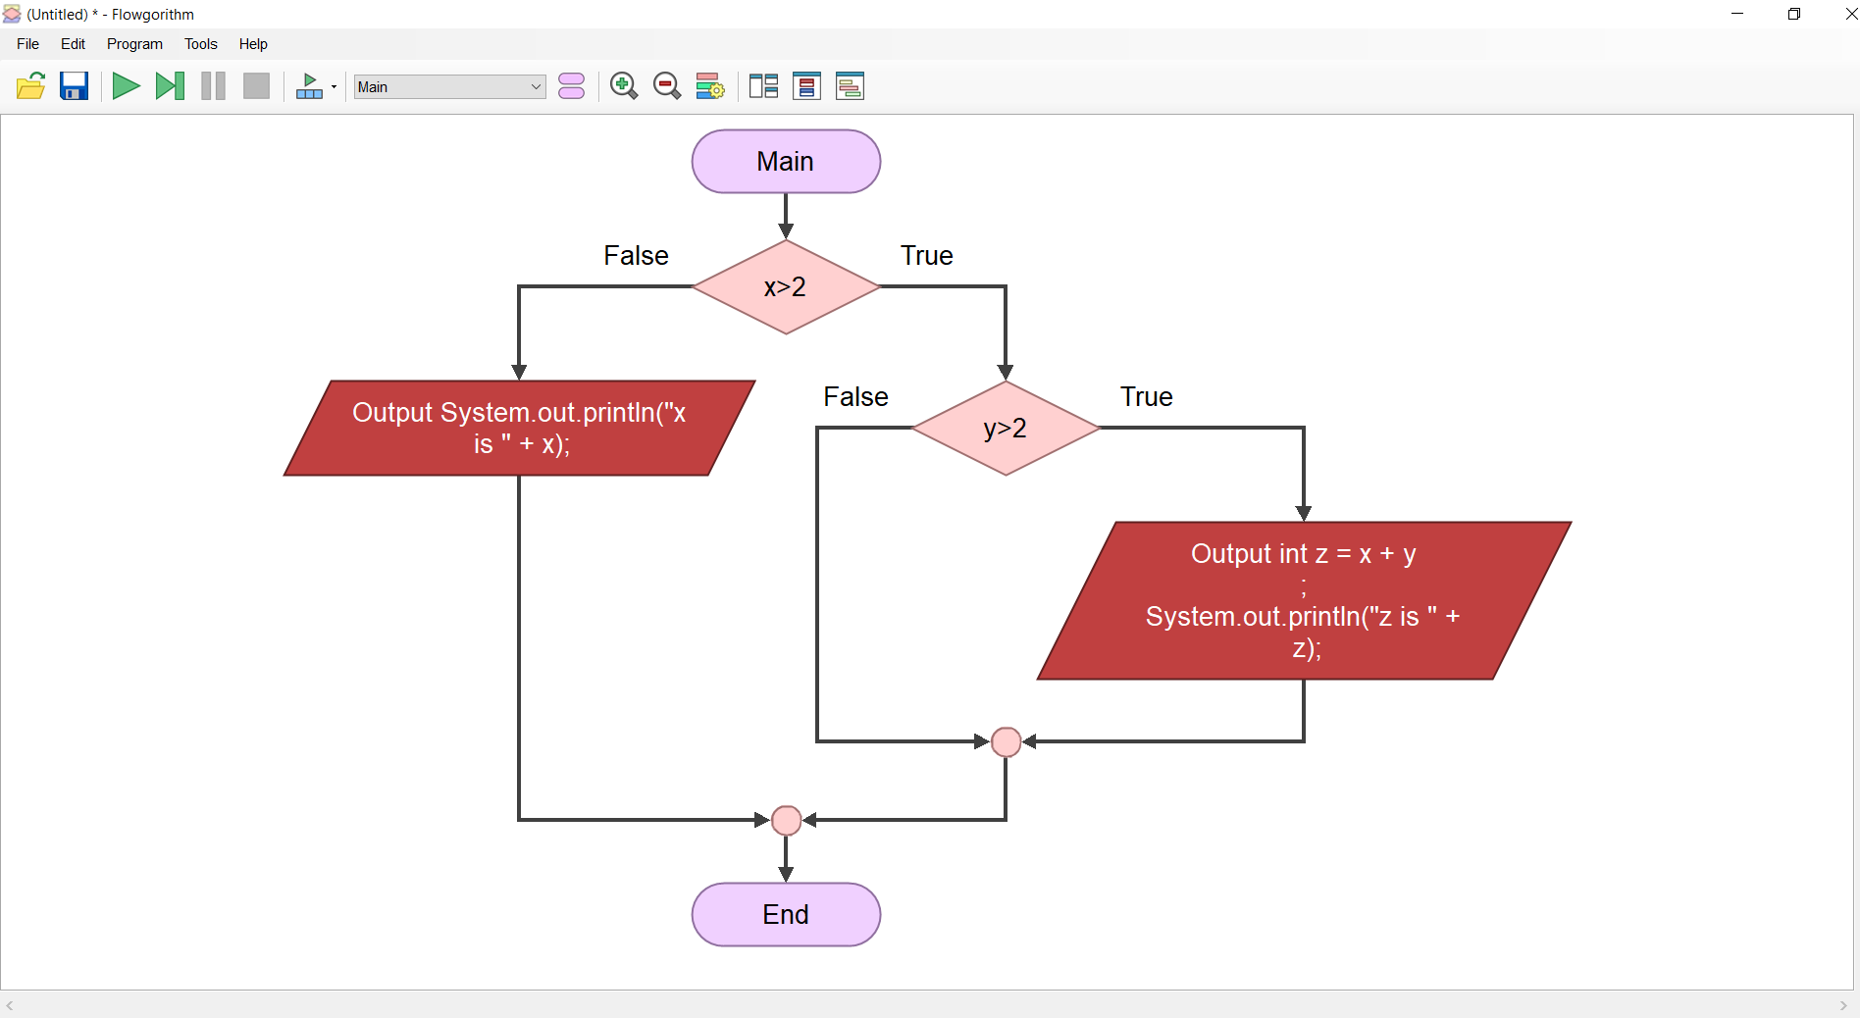

#3.5.3 What is wrong with the following code?

**If the score is greater than or equal to 60 then everything greater than 60 is a d. 70, 80, 90 all D’s. It should start with 90 and descend.**

if (score >= 60.0)

System.out.println("D");

else if (score >= 70.0)

System.out.println("C");

else if (score >= 80.0)

System.out.println("B");

else if (score >= 90.0)

System.out.println("A");

else

System.out.println("F");

#3.6.1 Which of the following statements are equivalent? Which one are indented correctly?

**a, c and d are all equivalent, but only B and C are indented correctly.**

1. If (I > 0) if (c)

(j > 0) if (I > 0)

X = 0; else if (j > 0)

If (k > 0) y = 0; x = 0;

else z = 0; else if (k > 0)

1. If (I > 0){ y = 0;

If(j > 0) else

X = 0; z = 0;

else if (k >0)

Y = 0; (d)

} if (I > 0)

Else if (j > 0)

Z = 0; x = 0;

else if (k > 0)

y = 0;

else

z = 0;

#3.6.3 Are the following statements correct? Which one is better?

**They are both correct statements, but b is the better statement.**

(a)

if (age < 16)

System.out.println

("Cannot get a driver's license");

if (age >= 16)

System.out.println

("Can get a driver's license");

(b)

if (age < 16)

System.out.println

("Cannot get a driver's license");

else

System.out.println

("Can get a driver's license");

#3.7.2 a. How do you generate a random integer i such that 0 <= i < 20 ?

**(int)(Math.random()*20)**

b. How do you generate a random integer i such that 10 <= i < 20

**10 + (int)(Math.random()*10)**

c. How do you generate a random integer i such that 10 <= i <= 50

**10 + (int)(Math.random()*41)**

d. Write an expression that returns 0 or 1 randomly.

**(int)(Math.random()*2)**

#3.10.1 Assuming that x is 1, show the result of the following Boolean expressions.

(true) && (3 > 4)  **false**

!(x > 0) && (x > 0)  **false**

(x > 0) || (x < 0)  **true**

(x != 0) || (x == 0) **true**

(x >= 0) || (x < 0)  **true**

(x != 1) == !(x == 1)  **true**

#3.10.4 Assume that x and y are int type. Which of the following are legal Java expressions?

**X /= y is the only correct statement**

x > y > 0

x = y && y

x /= y

x or y

x and y

(x != 0) || (x = 0)

#3.10.7 Suppose, when you run the following program, you enter the input 2 3 6 from the console. What is the output?

**(x < y && y < z) is true**

**(x < y || y < z) is true**

**!(x < y) is false**

**(x + y < z) is true**

**(x + y > z) is false**

public class Test {

public static void main(String[] args) {

java.util.Scanner input = new java.util.Scanner(System.in);

double x = input.nextDouble();

double y = input.nextDouble();

double z = input.nextDouble();

System.out.println("(x < y && y < z) is " + (x < y && y < z));

System.out.println("(x < y || y < z) is " + (x < y || y < z));

System.out.println("!(x < y) is " + !(x < y));

System.out.println("(x + y < z) is " + (x + y < z));

System.out.println("(x + y > z) is " + (x + y > z));

}

}

#3.10.11 Write a Boolean expression that evaluates to true if either weight is greater than 50 pounds or height is greater than 60 inches, but not both.

**weight > 50 ^ height > 60.**

#3.13.2 What is y after the following switch statement is executed? Rewrite the code using an if-else statement.

**y is 2.**

**x = 3; y = 3;**

**if (x + 3 == 6) {**

**y = 1;**

**}**

y += 1;

x = 3; y = 3;

switch (x + 3) {

case 6: y = 1;

default: y += 1;

}

#3.13.4 Write a switch statement that displays Sunday, Monday, Tuesday, Wednesday, Thursday, Friday, Saturday, if day is 0, 1, 2, 3, 4, 5, 6, accordingly.

**switch (day) {**

**case 0: System.out.println("Sunday"); break;**

**case 1: System.out.println("Monday"); break;**

**case 2: System.out.println("Tuesday"); break;**

**case 3: System.out.println("Wednesday"); break;**

**case 4: System.out.println("Thurday"); break;**

**case 5: System.out.println("Friday"); break;**

**case 6: System.out.println("Saturday"); break;**

**}**

#3.15.3 Evaluate the following expressions:

2 * 2 - 3 > 2 && 4 - 2 > 5  **false**

2 * 2 - 3 > 2 || 4 - 2 > 5 **false**

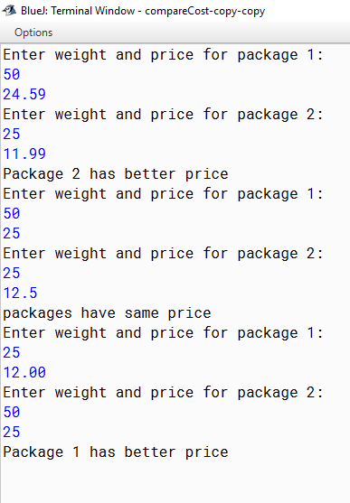**Compare Cost Output**